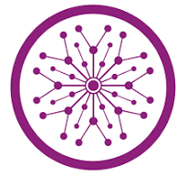

SUPERIOR UNIVERSITY LAHORE
GOLD CAMPUS

NAME: MUHAMMAD MOIZ RAZA
ROLL NO: SU92-BSAIM-F24-061
PROGRAM: ARTIFICIAL INTELLIGENCE
SEMESTER: 4th SEMESTER
SECTION: BSAI-4A
SUBJECT: PROGRAMMING OF AI (LAB)

Submission Title: LAB TASK 1
Submitted To: Sir Rasikh Ali

TITLE: WEB SCRAPPING

OVERVIEW:
It is a simple web-based application developed using Python and Flask that allows users to extract email addresses from web pages. In this application, users enter the URL of a webpage through a web interface, and the system automatically scans the page to find any email addresses available in the content.

Technologies Used

Backend
- Python 3 – Main programming language used to implement the scraping logic.
- Flask – Used to create the web server and handle routes, form submissions, and responses.
- Requests – Used to send HTTP requests and fetch webpage content.
- BeautifulSoup (bs4) – Used to parse HTML and extract text from the webpage.
- Regular Expressions (re) – Used to detect email address patterns in the page content.
- CSV / OS Modules – Used for storing and managing scraped email data in a CSV file.

Frontend
- HTML – Used to create the structure of the web page and input form.
- CSS – Used to style the interface and improve the visual appearance of the application.

FEATURES :
The application allows users to enter a webpage URL and automatically extract email addresses from the page. It displays the found emails, removes duplicates, and saves them in a CSV file for future use. Users can also view previously saved emails and download the complete data as a CSV file.

Working:
The application works by allowing users to enter a webpage URL through the web interface. It sends a request to fetch the webpage content, parses the HTML, and searches for email addresses using regular expressions. The extracted emails are then displayed to the user and stored in a CSV file.

Uses:
This tool can be used to quickly collect email addresses from websites for research, data collection, or educational purposes. It also helps demonstrate basic concepts of web scraping, data extraction, and web application development using Python and Flask.

Screenshot:
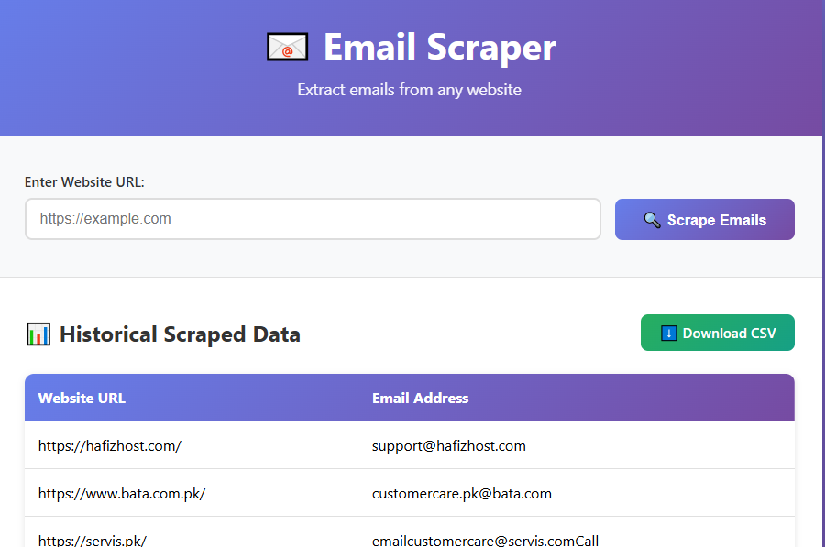

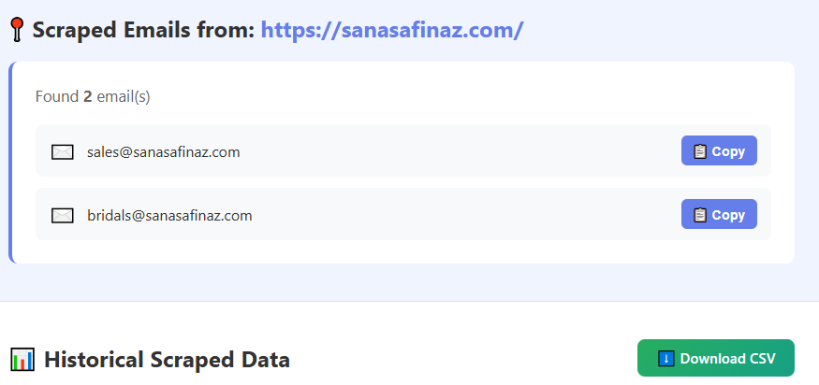

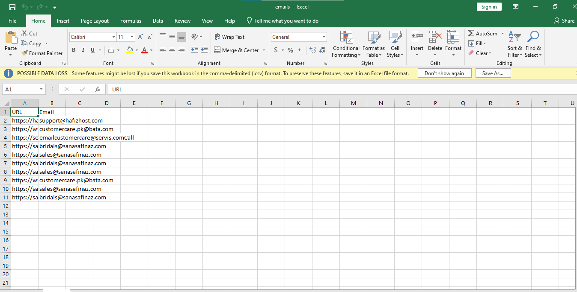

THE END

